Worksheet 2

Student Name: Manish Kr. Mishra UID: 25MCA20185
Branch: MCA General Section/Group: 2-A
Semester: 3rd Date of Performance:04/08/26
Subject Name: Machine Learning Subject Code: 25CAP-702

Aim:

To implement Linear Regression using Python and Scikit-Learn on a real-world dataset, plot the best fit regression line, and evaluate the model using MSE and RMSE.
Objective:
Implementation of Linear Regression using Python in Jupyter Notebook and evaluation using MSE and RMSE.
Software Requirements:
- Python
- VS Code / Any Text Editor
- Command Prompt / Terminal
Procedure/Algorithm/Code:
import pandas as pd
import numpy as np
import matplotlib.pyplot as plt

from sklearn.model_selection import train_test_split
from sklearn.linear_model import LinearRegression
from sklearn.metrics import mean_squared_error

df = pd.read_csv("student-scores.csv")

# Step 3: Display Dataset Information
print("First 5 Rows of Dataset:")
print(df.head())

print("\nDataset Shape:")
print(df.shape)

print("\nDataset Information:")
print(df.info())

print("\nMissing Values:")
print(df.isnull().sum())

X = df[['weekly_self_study_hours']]

# Dependent Variable
y = df['total_score']

# Step 5: Split Dataset into Training and Testing Sets
X_train, X_test, y_train, y_test = train_test_split(
X,
y,
test_size=0.2,
random_state=42
)

# Step 6: Create Linear Regression Model
model = LinearRegression()

# Step 7: Train the Model
model.fit(X_train, y_train)

# Step 8: Predict Test Data
y_pred = model.predict(X_test)

# Step 9: Display Regression Equation
print("\nRegression Equation")
print("----------------------")
print("Slope (Coefficient):", model.coef_[0])
print("Intercept:", model.intercept_)

# Step 10: Calculate Mean Squared Error (MSE)
mse = mean_squared_error(y_test, y_pred)
print("\nMean Squared Error (MSE):", mse)

# Step 11: Calculate Root Mean Squared Error (RMSE)
rmse = np.sqrt(mse)
print("Root Mean Squared Error (RMSE):", rmse)

# Step 12: Compare Actual and Predicted Values
comparison = pd.DataFrame({
'Actual': y_test.values,
'Predicted': y_pred
})

print("\nActual vs Predicted Values")
print(comparison)

# Step 13: Plot Best Fit Line
plt.figure(figsize=(8,6))

plt.scatter(X, y, color='blue', label='Actual Data')

plt.plot(X, model.predict(X), color='red', linewidth=2, label='Best Fit Line')

plt.xlabel('Study Hours')
plt.ylabel('Scores')
plt.title('Linear Regression Best Fit Line')
plt.legend()
plt.grid(True)

plt.show()
Output:
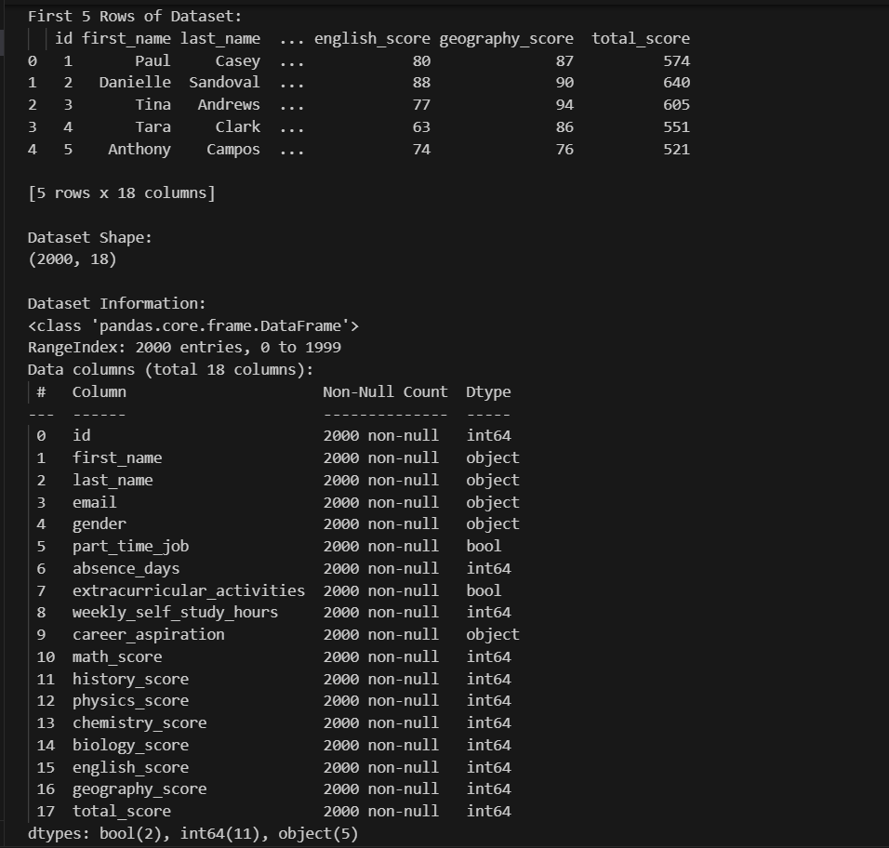
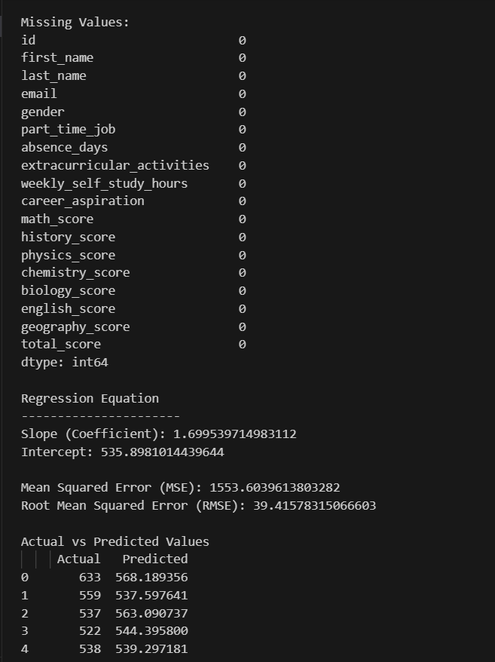
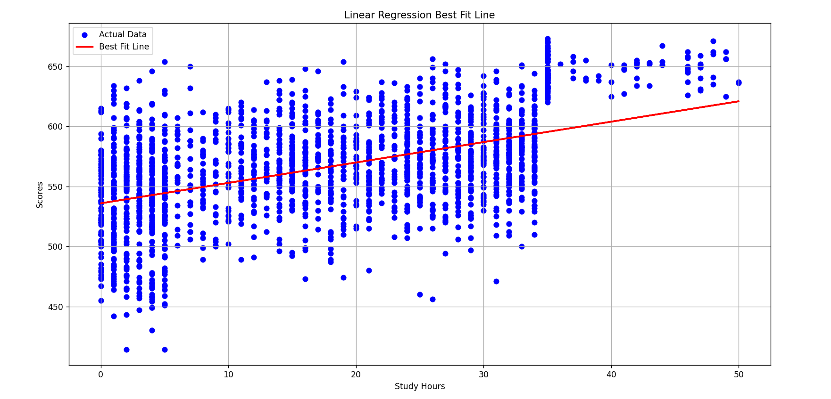
Learning Outcome:
After completing this experiment, I was able to:
- Understand the concept of Linear Regression.
- Import and preprocess datasets using Python libraries.
- Implement Linear Regression using Scikit-Learn.
- Visualize the best fit regression line.
- Evaluate model performance using MSE and RMSE.
- Interpret regression model results.
Evaluation Grid :
Sr. No. | Parameters | Marks Obtained | Maximum Marks
1. | Worksheet Completion |  | 08 marks
2. | Conduct |  | 12 marks
3. | Viva Voice |  | 10 marks
 | Total |  | 30 marks

